Beyond Failing to Reject: A Bayesian Approach to Evaluating the Andilaye WASH Intervention

Background: Research Question & Data
The Andilaye trial was a parallel cluster-randomized controlled trial conducted in rural and peri-urban Amhara, Ethiopia, testing whether a demand-side water, sanitation, and hygiene (WASH) promotion intervention could improve sustained WASH behavior and mental well-being relative to standard programming (Delea et al., 2019; Freeman et al., 2022). Fifty kebeles across three woredas were randomly assigned to intervention or control, with household-level outcomes measured at baseline and approximately two years later at endline.
The original published analysis using Generalized Estimating Equations (GEE) and a subsequent reanalysis using mixed-effects logistic regression both yielded non-significant results for all three mental health outcomes, including depression, anxiety, and emotional distress. However, a non-significant p-value cannot distinguish between two substantively different situations: (1) the intervention truly has no meaningful effect, or (2) the study had insufficient power to detect a real effect as mental well-being was a secondary outcome in the Andilaye trial. This ambiguity is particularly consequential in implementation science, where null results are frequently used to de-prioritize or discontinue programs without any quantification of how confident we actually are that effects are small.
A Bayesian reanalysis resolves this ambiguity in two ways. First, by computing the posterior probability that the treatment effect on the probability scale, expressed as an Average Predictive Difference (APD), falls inside a Region of Practical Equivalence (ROPE), we can accumulate positive evidence for a practically null effect rather than merely failing to reject. The APD is the natural estimand for an implementation science audience: it answers directly how many fewer households would screen positive for a mental health disorder if the intervention were delivered. Second, the Bayesian hierarchical model yields a full posterior distribution for the between-cluster variance, providing a meaningful characterization of cluster-level heterogeneity that neither GEE nor frequentist mixed-effects models directly supply.
This study reanalyzes the Andilaye trial data using a Bayesian hierarchical framework to address two research questions. First, what is the posterior probability that the APD, defined as the average difference in predicted probability between intervention and control households, falls within a Region of Practical Equivalence (ROPE) around zero for each of the three mental health outcomes? A high posterior probability inside the ROPE constitutes positive evidence for a practically null effect, which is qualitatively different from a failure to reject. Second, what is the full posterior distribution of between-cluster variance in mental health outcomes across the 50 kebeles, and what does it imply about the degree of clustering in this population? The ROPE boundary and its substantive justification are defined in Section 2.
The outcomes for this study include three binary household-level indicators constructed from a 23-item HSCL adaptation: 10 anxiety items and 13 depression items, each scored 0 to 3. Individual-level subscale means were averaged across eligible household members, and a combined distress mean was computed across all 23 items. A probable case of depression, anxiety, and emotional distress was assigned at a threshold of >= 1.75 on the original 1-to-4 scale. Treatment is a binary indicator (1 = intervention, 0 = control) assigned at the kebele level. Woreda is included as a fixed covariate to account for stratified randomization with Farta as the reference. Kebele is the unit of randomization and the clustering variable for random intercepts.
The dataset is publicly accessible (Freeman et al., 2022) and was obtained for prior coursework. The primary analytic sample is the endline survey. A panel dataset linking endline to baseline outcomes by household ID is used for a sensitivity model for model comparison. After filtering to completed interviews, the endline sample comprises 1,472 households in 50 kebeles (25 intervention, 25 control). Item-level missingness is negligible (12 of 4,371 respondents, 0.3%); no household has a missing outcome after aggregation. Baseline balance across arms was reported in Delea et al. (2019, Table 1); endline sample characteristics are shown in Table 1.
Table 1: Endline analytic sample characteristics by treatment arm
Characteristic | Overall  N = 1,472 | Intervention  N = 743 | Control  N = 729
Woreda
Farta | 655 (44.5%) | 332 (44.7%) | 323 (44.3%)
Fogera | 339 (23.0%) | 170 (22.9%) | 169 (23.2%)
Bahir Dar Zuria | 478 (32.5%) | 241 (32.4%) | 237 (32.5%)
Anxiety | 346 (23.5%) | 165 (22.2%) | 181 (24.8%)
Depression | 229 (15.6%) | 105 (14.1%) | 124 (17.0%)
Emotional distress | 273 (18.5%) | 124 (16.7%) | 149 (20.4%)
Households per kebele [median (min-max)] | 29 (25-33) | 29 (25-33) | 29 (27-33)
Note: Screen-positive threshold: household mean item score >= 1.75 on the 1-4 scale.

Model Specification
We fitted a Bayesian hierarchical logistic regression separately for each of the three binary outcomes (anxiety, depression, emotion). Let i index households (I = 1, …, N), j[i] index the kebele cluster for household i (j = 1, …, N), and w[i] ∈ {1, 2, 3} denote the woreda index.
Likelihood
Each binary outcome y_{i} is modeled as:
$$y_{i}|p_{i}=Bernoulli(p_{i})$$
$$logit\left(p_{i}\right)= α_{j[i]}+β_{trt}×{x_{i}}^{trt}+γ_{w[i]}$$
where ${x_{i}}^{trt}$ is the binary treatment indicator (1 = intervention, 0 = control), $α_{j[i]}$ is the random intercept for kebele j[i], and $γ_{w[i]}$ is the fixed woreda effect. Farta is the reference category, enforced by the constraint $γ_{1}=0$.
Cluster-level random intercepts
Kebele intercepts are modeled as exchangeable draws from a common Normal distribution:
$$α_{j}|μ_{0},σ_{cluster}\sim Normal\left(μ_{0}, {σ^{2}}_{cluster}\right), j=1,…, 50$$
This partial-pooling structure allows each cluster to have its own baseline log-odds while borrowing information across clusters. Exchangeability is justified by the study design: kebeles were randomly selected and randomly assigned, and there is no a priori reason to expect any particular kebele to differ from the others in ways not already captured by the woreda fixed effects.
Prior distributions
$$β_{trt}\sim Normal\left(0, 1\right) \\ γ_{1}=0, γ_{2},γ_{3}\sim Normal\left(0, 1\right) \\ μ_{0}\sim Normal(-1.1, {0.5}^{2})$$$σ_{cluster}\sim \text{Half}\text{-}Normal(0, {0.5}^{2})$
The prior on $β_{trt}$ is weakly informative and centered at zero, placing 95% of its mass between log-ORs of approximately $-2$and $+2$(odds ratios 0.14 to 7.4), reflecting genuine equipoise about the direction and magnitude of any treatment effect. For the grand-mean log-odds $μ_{0}$, we used a substantively informed prior $Normal(-1.1, {0.5}^{2})$, which encodes the observed baseline caseness prevalence of approximately 25% (${\text{logit}}^{-1}(-1.1)≈0.25$) while remaining permissive across the range of roughly 11% to 47%. For the between-kebele standard deviation $σ_{\text{cluster}}$, we used a Half-$Normal(0, {0.5}^{2})$ prior rather than the heavier-tailed Half-$t(3, 0, 2.5)$ recommended by Gelman (2006), anchoring the implied intraclass correlation coefficient (ICC) near the range consistent with mental health outcomes in cluster-randomized trials more broadly: a meta-analysis of cluster-randomized controlled trials in major depression reported a pooled ICC of 0.07 (95% CI: 0.05, 0.09) (Bhaskarapillai et al., 2025), and a compendium of multilevel implementation trials in mental health reported similarly modest clustering (Williams et al., 2024).
These two structural priors import information that is directly available from the trial itself and the published clustering literature, and the prior predictive check in Section 3 confirms they generate outcome prevalences consistent with the observed data before any endline outcomes are conditioned upon. The ROPE bounds of $\left[-0.05,+0.05\right]$ on the APD scale are chosen to represent the threshold of practical equivalence for a community-level demand-side behavioral intervention: a difference of less than 5 percentage points in probable case probability between intervention and control households is unlikely to be detectable at the program level, to motivate reallocation of resources, or to be meaningful to implementers or policymakers in this context. This threshold is adapted from Kruschke’s (2018) ROPE framework, which defines a ROPE around a null value within which parameter values are considered negligible for decision-making purposes. The ROPE analysis is not predetermined by the choice of structural priors: because $β_{trt}$ remains centered at zero and unchanged across models, the prior predictive distribution of the APD is also centered at zero with substantial mass both inside and outside the ROPE, meaning the posterior probability inside the ROPE is determined by the data rather than by the prior on the baseline prevalence or clustering structure. A sensitivity analysis replacing the informed structural priors with weakly informative alternatives ($μ_{0}∼Normal(0, 1^{2})$, $σ_{\text{clus}\text{ter}}∼\text{Half-}t(3, 0, 2.5)$) is reported in the Appendix; the conclusions remain unchanged across all three outcomes.
Primary estimand: Average Predictive Difference (APD)
The structural parameter $β_{trt}$ operates on the log-odds scale and is not directly interpretable. The quantity that directly answers the research question is the APD, which is the average difference in predicted probability of screening positive between intervention and control, integrating over the full posterior uncertainty in all model parameters. For each posterior draw s:
$$\hat{APD^{\left(s\right)}} = \frac{1}{N} \sum_{i=1}^{N}{\left[\frac{1}{1+e^{-\left(α_{j\left[i\right]}^{\left(s\right)}+β_{trt}^{\left(s\right)}+γ_{w\left[i\right]}^{\left(s\right)}\right)}}-\frac{1}{1+e^{-\left(α_{j\left[i\right]}^{\left(s\right)}+γ_{w\left[i\right]}^{\left(s\right)}\right)}}\right]}$$
We report the posterior mean, 95% high density interval (HDI), the posterior probability that locate inside the ROPE, and the reciprocal of APD as the Number Needed to Treat (NNT). We also report the posterior distribution of $σ_{\text{clus}\text{ter}}$ and the implied ICC computed draw-by-draw as $\frac{σ_{cluster}^{\left(s\right)2}}{\frac{π^{2}}{3} + σ_{cluster}^{\left(s\right)2}}$.
Model with One Pre-Randomization Covariate: ANCOVA
A second model augments the linear predictor with each household’s baseline screening status $y_{i}^{\text{bl}}∈\{0,1\}$, measured at the time of enrollment before randomization:
$$\text{logit}(p_{i})=α_{j[i]}+β_{\text{trt}}⋅x_{i}^{\text{trt}}+γ_{w[i]}+δ⋅y_{i}^{\text{bl}},δ∼Normal(0, 1)$$ Conditioning on the baseline outcome is causally justified because it was measured prior to randomization and therefore cannot be affected by treatment assignment. It is also justified on efficiency grounds: households that screened positive at baseline are more likely to screen positive at endline regardless of treatment, and adjusting for this pre-existing tendency reduces residual variance and sharpens the estimate of $β_{\text{trt}}$. The primary and ANCOVA models are compared using PSIS-LOO on the common subsample of 1,468 households for whom a baseline record is available, with 4 households excluded due to missing baseline data. If the ANCOVA model is favored by more than 2 standard errors in expected log pointwise predictive density, we report APD estimates from both models and discuss any discrepancy; otherwise, the primary model is retained on parsimony grounds, and the 4 households with missing baseline records are kept in the analysis without additional assumptions.

Prior Predictive Check

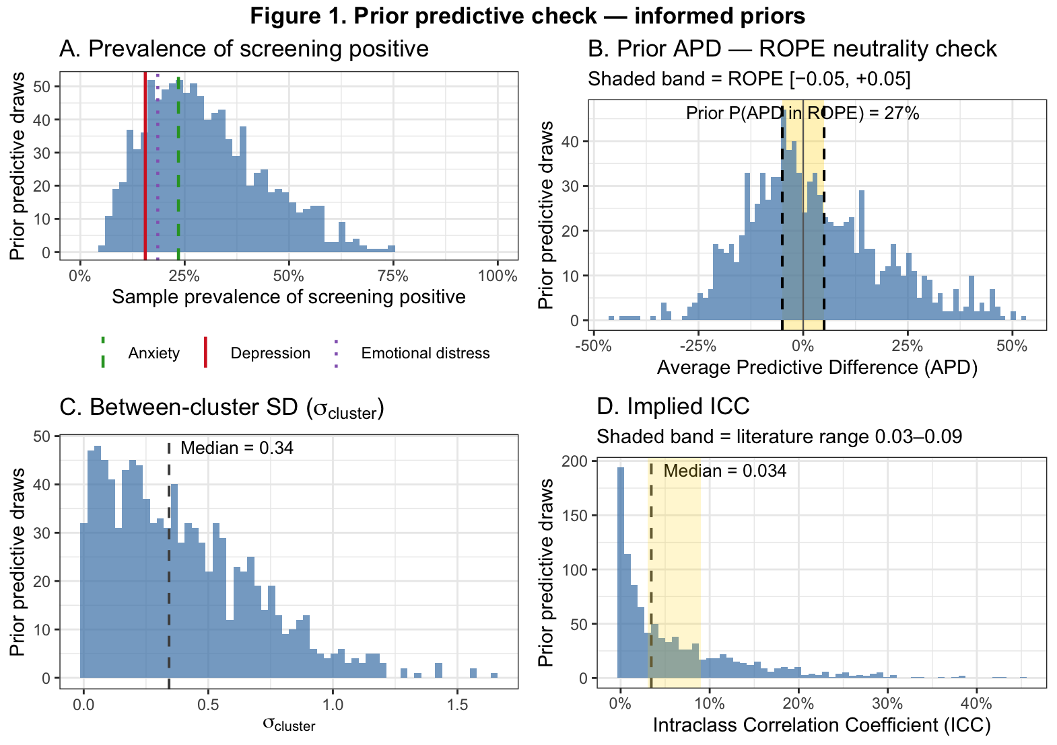
Figure 1 displays prior predictive distributions of four quantities derived from 1,000 draws from the informed priors alone, before conditioning on any endline outcome data. Panel A confirms the grand-mean prior $μ_{0}\sim Normal(-1.1, {0.5}^{2})$ generates plausible prevalences of screening positive: the distribution is concentrated between 10% and 50%, and all three observed endline prevalences (depression 15.6%, emotional distress 18.5%, anxiety 23.5%) fall comfortably within its bulk. Panel B shows the prior APD is centered at zero with only 27% of draws inside the ROPE [-0.05, +0.05], confirming the ROPE analysis is not predetermined by the prior. Panels C and D characterize the prior clustering structure: $σ_{\text{clus}\text{ter}}$ has a prior median of 0.34 on the log-odds scale, implying a prior ICC median of 0.034, which sits at the lower boundary of the 0.03 to 0.09 range reported for mental health outcomes in cluster-randomized trials (Bhaskarapillai et al., 2025; Williams et al., 2024). Taken together, the four panels confirm the informed priors are consistent with substantive knowledge about this trial and this literature while remaining genuinely open to the data.

Fitting & Model Comparison
All models were fit in R using JAGS via the rjags interface, which implements Gibbs sampling. Nine models were fit in total: three outcomes (anxiety, depression, emotional distress) across three specifications (primary, ANCOVA, and weakly informative priors, with the latter reported in the Appendix). Each model was run on 4 independent chains rather than the conventional 3, to improve the reliability of the Gelman-Rubin $\hat{R}$ convergence diagnostic and increase effective sample size (ESS) for the hierarchical variance parameter $σ_{\text{clus}\text{ter}}$, which is known to mix slowly in logistic models with moderate cluster sizes. Each chain ran for 10,000 burn-in iterations that were discarded, followed by 20,000 post-burn-in iterations thinned by a factor of 2, yielding 10,000 draws per chain and 40,000 total posterior draws per model. The extended burn-in and larger number of post-burn-in iterations were chosen specifically to allow $σ_{\text{clus}\text{ter}}$ and $μ_{0}$sufficient time to reach stationarity and accumulate an adequate ESS, as preliminary runs with shorter chains showed marginal effective sample sizes for these parameters. Chain-specific RNG seeds were passed directly to JAGS via .RNG.name and.RNG.seed arguments in the inits list, ensuring exact reproducibility across machines and sessions.
Following model fitting, the primary and ANCOVA models were compared using PSIS-LOO on the common subsample of 1,468 households for whom baseline screening status was available. The ANCOVA model was favored for all three outcomes, with differences in expected log pointwise predictive density exceeding the pre-specified threshold of 2 standard errors in all cases ($Δ$ELPD = $-19.08$, $-12.75$, and $-12.17$for anxiety, depression, and emotional distress, respectively). Per the decision rule stated in Section 2, all posterior inference reported in Sections 5 through 7 is therefore based on the ANCOVA models. Primary model results are retained in the LOO comparison table for transparency and show no meaningful difference in substantive conclusions regarding the treatment effect (see Appendix).
Table 2. PSIS-LOO Comparison on the Common 1,468-Household Subsample
Outcome | ELPD primary | ELPD ANCOVA | ΔELPD | SE(Δ) | Favors
Anxiety | -801.7 | -782.6 | -19.08 | 6.27 | ANCOVA
Depression | -629.2 | -616.5 | -12.75 | 5.22 | ANCOVA
Emotion | -704.2 | -692.0 | -12.17 | 5.15 | ANCOVA

MCMC Diagnostics
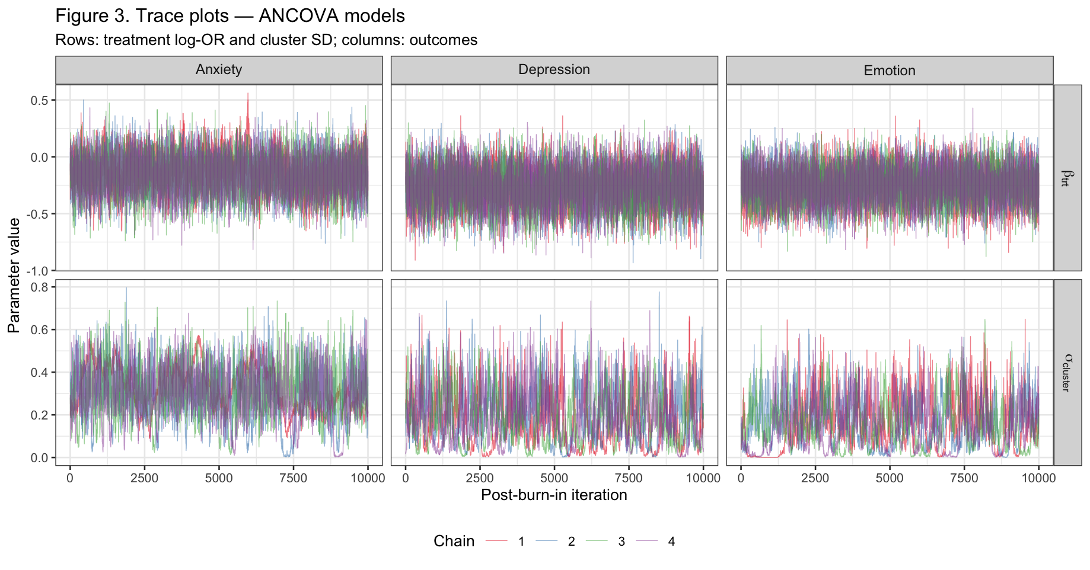
Table 3. MCMC Convergence Diagnostics – ANCOVA Models.
Outcome | Parameter | $$\hat{R}$$ | $\hat{R}$ (UCI) | ESS
Anxiety | $$β_{\text{trt}}$$ | 1.005 | 1.016 | 4547
Anxiety | $$γ_{2}$$ | 1.005 | 1.016 | 5330
Anxiety | $$γ_{3}$$ | 1.009 | 1.026 | 4275
Anxiety | $$μ_{0}$$ | 1.019 | 1.055 | 1423
Anxiety | $$σ_{cluster}$$ | 1.017 | 1.043 | 481
Anxiety | $$α_{[1:50]}$$ | 1.006 | 1.019 | 4682
Depression | $$β_{\text{trt}}$$ | 1.001 | 1.004 | 2666
Depression | $$γ_{2}$$ | 1.001 | 1.004 | 3423
Depression | $$γ_{3}$$ | 1.002 | 1.005 | 3174
Depression | $$μ_{0}$$ | 1.009 | 1.024 | 638
Depression | $$σ_{cluster}$$ | 1.015 | 1.044 | 399
Depression | $$α_{[1:50]}$$ | 1.004 | 1.009 | 1787
Emotion | $$β_{\text{trt}}$$ | 1.000 | 1.001 | 2786
Emotion | $$γ_{2}$$ | 1.001 | 1.002 | 3197
Emotion | $$γ_{3}$$ | 1.001 | 1.002 | 3015
Emotion | $$μ_{0}$$ | 1.002 | 1.006 | 654
Emotion | $$σ_{cluster}$$ | 1.012 | 1.036 | 301
Emotion | $$α_{[1:50]}$$ | 1.002 | 1.006 | 1577
Note: For $α_{[1:50]}$, $\hat{R}$is the median point estimate and $\hat{R}$ (UCI) is the maximum point estimate across the 50 cluster intercepts; ESS is the median. Rows highlighted indicate R-hat > 1.01 or ESS < 400.
Table 3 reports the Gelman-Rubin $\hat{R}$statistic and effective sample size for all monitored parameters across the three ANCOVA models, and Figure 3 shows trace plots for $β_{\text{trt}}$and $σ_{\text{cluster}}$across all four chains. For $β_{\text{trt}}$and the woreda fixed effects, convergence was satisfactory across all three outcomes, with $\hat{R}$point estimates below 1.01 and ESS ranging from 2,666 to 5,330. The kebele-level random intercepts $α_{j}$converged well, with median $\hat{R}$below 1.007 and median ESS above 1,577. The grand-mean parameter $μ_{0}$showed slower convergence, with $\hat{R}$ reaching 1.019 for anxiety and ESS ranging from 638 to 1,423. As expected, $σ_{\text{cluster}}$showed the slowest mixing across all outcomes, with ESS between 301 and 481 and $\hat{R}$ between 1.012 and 1.017, reflecting the funnel pathology inherent to hierarchical variance parameters in logistic models.
Autocorrelation of $β_{\text{trt}}$shown in Figure 4 remains elevated beyond lag 30, a known limitation of Gibbs sampling in correlated hierarchical posteriors that we acknowledge as a limitation of the current implementation. Despite these limitations, ESS for $β_{\text{trt}}$remains adequate for reliable posterior inference across all three outcomes, and the trace plots confirm good stationarity and chain overlap for the parameter most central to the research question.
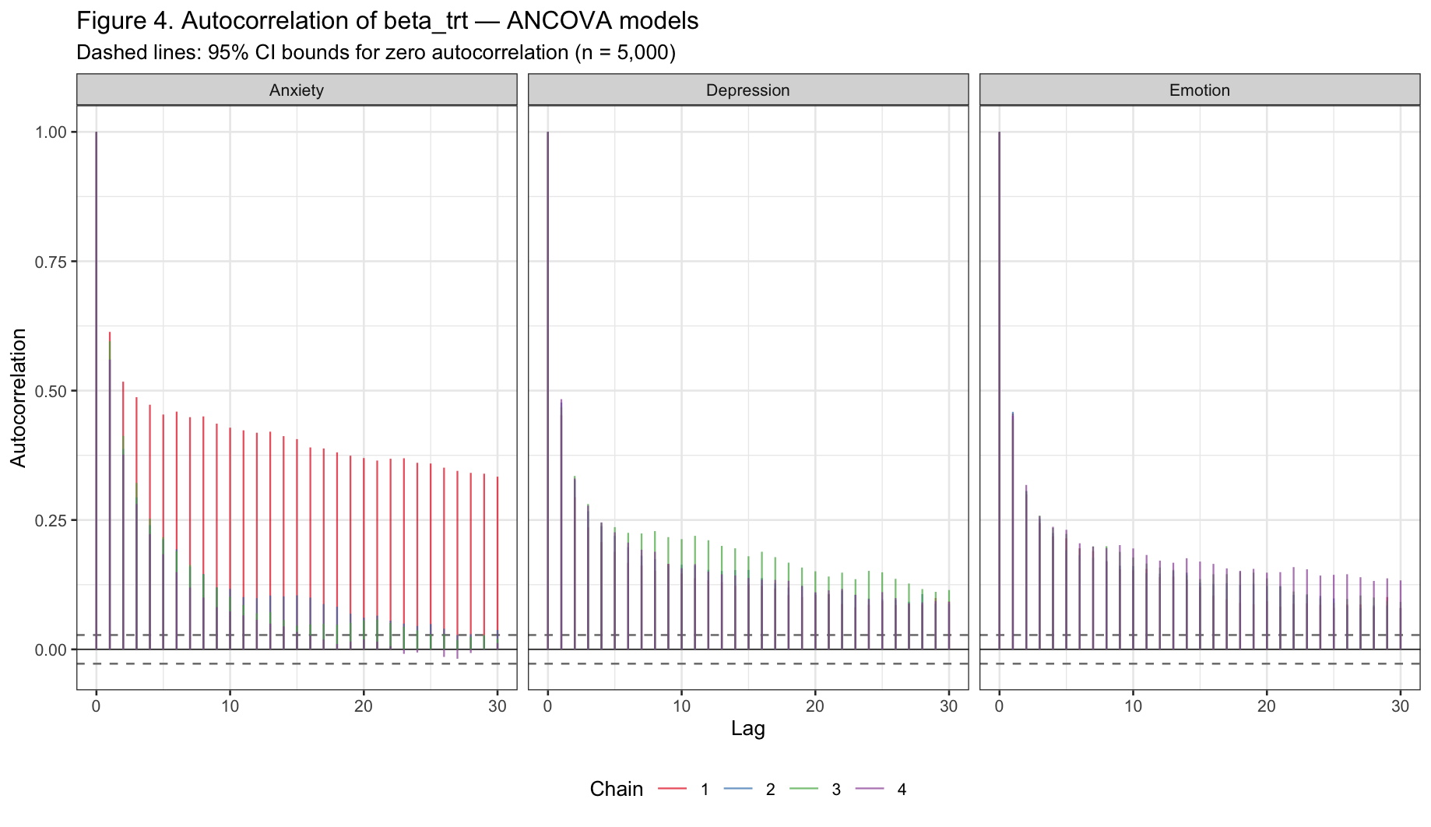

Posterior Inference
Average Predictive Difference
Table 4. Posterior Average Predictive Difference – ANCOVA Models.
Outcome | APD | 95% HDI | P(ROPE) | NNT
Anxiety | -0.023 (0.023) | [-0.067, 0.024] | 88.5% | 44
Depression | -0.030 (0.018) | [-0.064, 0.004] | 87.2% | 33
Emotion | -0.033 (0.019) | [-0.070, 0.004] | 82.2% | 30
Note: APD reported as posterior mean (SD). 95% HDI = Highest Density Interval. P(ROPE) = posterior probability that |APD| < 0.05. NNT = Number Needed to Treat, computed as 1/|mean APD|. ROPE = Region of Practical Equivalence [-0.05, +0.05].

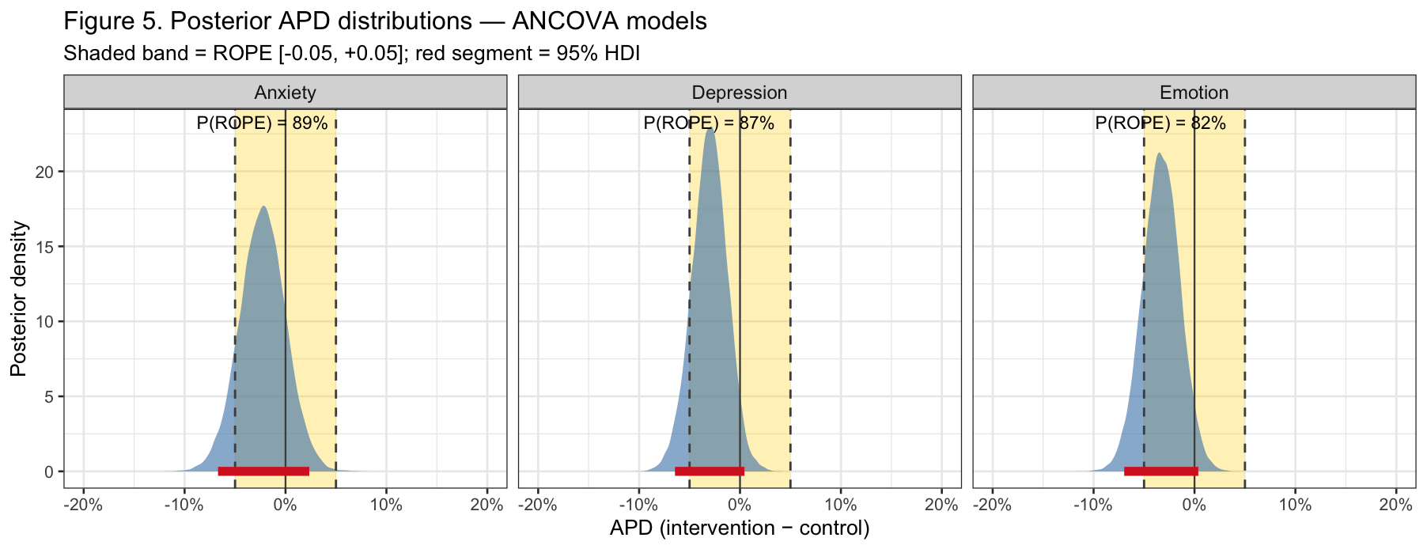
Table 3 and Figure 5 report the posterior APD distributions for all three outcomes under the ANCOVA model. Across all three outcomes, the posterior distributions are tightly concentrated around small negative values, with posterior means of -0.023, -0.030, and -0.033 for anxiety, depression, and emotional distress, respectively, indicating a slight tendency toward lower screening-positive probability in the intervention arm. However, all three posteriors are well within the ROPE [-0.05, +0.05]: the posterior probability inside the ROPE is 88.5% for anxiety, 87.2% for depression, and 82.2% for emotional distress. While none of these exceed the 95% threshold that would constitute strong evidence for a practically null effect, all three are well above 50%, meaning the data are substantially more consistent with a negligible effect than with a practically meaningful one in either direction. The 95% HDIs corroborate this: [-0.067, 0.024] for anxiety, [-0.064, 0.004] for depression, and [-0.070, 0.004] for emotional distress, all straddling zero and entirely or nearly entirely within the ROPE boundaries. The implied Number Needed to Treat ranges from 30 households for emotional distress to 44 for anxiety. Taken together, these results provide substantial though not decisive positive evidence that the Andilaye WASH intervention had no practically meaningful effect on household mental health at endline.
Between-Cluster Variance
Table 5. Posterior Between-Cluster Variance – ANCOVA Models.
Outcome | $$σ_{cluster}$$ | ICC
Anxiety | 0.300 [0.052, 0.515] | 0.030 [0.000, 0.065]
Depression | 0.183 [0.002, 0.402] | 0.014 [0.000, 0.047]
Emotion | 0.153 [0.000, 0.358] | 0.011 [0.000, 0.037]
Note: All estimates reported as posterior mean [95% Highest Density Interval].
$σ_{cluster}$ = between-kebele standard deviation on the log-odds scale. ICC = Intraclass Correlation Coefficient, computed draw-by-draw as $\frac{σ_{cluster}^{\left(s\right)2}}{\frac{π^{2}}{3} + σ_{cluster}^{\left(s\right)2}}$, where $\frac{π^{2}}{3}$ is the variance of the standard logistic distribution.
Table 4 and Figure 6 report the posterior distributions of $σ_{\text{cluster}}$and the implied ICC across the three outcomes. The posterior distributions of $σ_{\text{cluster}}$(Figure 6a) are right-skewed and concentrated near modest values, with posterior means of 0.300, 0.183, and 0.153 for anxiety, depression, and emotional distress, respectively. The wide 95% HDIs, spanning from near zero to approximately 0.515 for anxiety, reflect substantial uncertainty about the true degree of between-kebele heterogeneity, which is expected given that cluster-level variance parameters are weakly identified in logistic models with moderate cluster sizes. Notably, all three HDIs include values very close to zero, indicating the data are consistent with minimal between-cluster clustering for all outcomes. The implied ICC posteriors (Figure 6b) tell the same story: posterior means of 0.030, 0.014, and 0.011 for anxiety, depression, and emotional distress, respectively, with 95% HDIs spanning from essentially zero to at most 0.065. These estimates fall below or at the lower boundary of the 0.03 to 0.09 range reported in the literature (Bhaskarapillai et al., 2025; Williams et al., 2024), indicating that mental health outcomes in this Ethiopian population cluster only weakly at the kebele level, with most variation occurring between households rather than between communities. The full posterior distribution of the ICC, rather than a point estimate alone, is one of the key advantages of the Bayesian hierarchical approach over frequentist alternatives such as GEE, which do not directly quantify uncertainty about the clustering structure.
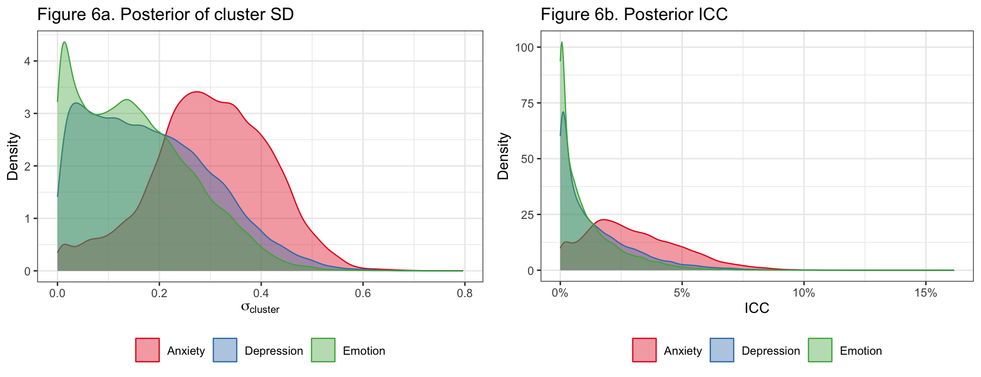

Posterior Predictive Check
Figures 7 and 8 and Table 6 together assess whether the fitted ANCOVA models generate data consistent with what was observed. Figure 7 shows the posterior predictive distribution of the overall prevalence of screening positive for each outcome. In all three panels, the observed prevalence (red line) falls close to the center of the replicated distribution, confirming the model is well calibrated at the population level. The bimodal appearance of the histograms reflects the between-kebele heterogeneity captured by the random intercepts, the two modes correspond roughly to clusters with lower and higher baseline prevalence.
Table 6. Posterior predictive p-values (PPP-values) – ANCOVA models
 | Anxiety |  | Depression |  | Emotion
Statistic | Obs. | PPP | Obs. | PPP | Obs. | PPP
Overall prevalence | 0.235 | 0.519 | 0.155 | 0.568 | 0.185 | 0.532
Treatment arm | 0.222 | 0.508 | 0.139 | 0.517 | 0.166 | 0.512
Control arm | 0.249 | 0.519 | 0.170 | 0.583 | 0.205 | 0.538
Woreda: Farta | 0.239 | 0.530 | 0.164 | 0.596 | 0.196 | 0.540
Woreda: Fogera | 0.246 | 0.509 | 0.196 | 0.496 | 0.205 | 0.510
Woreda: Bahir Dar Zuria | 0.222 | 0.507 | 0.113 | 0.518 | 0.157 | 0.514
Cluster prevalence SD | 0.092 | 0.584 | 0.078 | 0.631 | 0.080 | 0.604
Note: PPP-values near 0.5 indicate good calibration. Values near 0 or 1 indicate systematic discrepancy.
Table 6 extends this check to subgroups. All PPP values fall between 0.496 and 0.631 across all outcomes, treatment arms, and woredas, indicating no systematic bias in any subgroup. The cluster prevalence standard deviation PPP values of 0.584, 0.631, and 0.604 are slightly above 0.5, suggesting the model generates marginally more between-cluster variability than observed, consistent with the wide posterior distributions of $σ_{\text{cluster}}$noted in Section 6, but not indicative of serious misfit.
Figure 8 provides the most granular check, plotting observed against posterior predictive mean prevalence for each of the 50 kebeles separately, stratified by treatment arm. Points fall close to the 45-degree perfect calibration line across all three outcomes, and the 90% posterior predictive intervals cover the observed values for the large majority of kebeles. There is no systematic pattern of over- or underprediction for either the intervention or control arm. Taken together, the three checks provide no evidence of meaningful model misfit, supporting the adequacy of the ANCOVA hierarchical logistic model for these data.
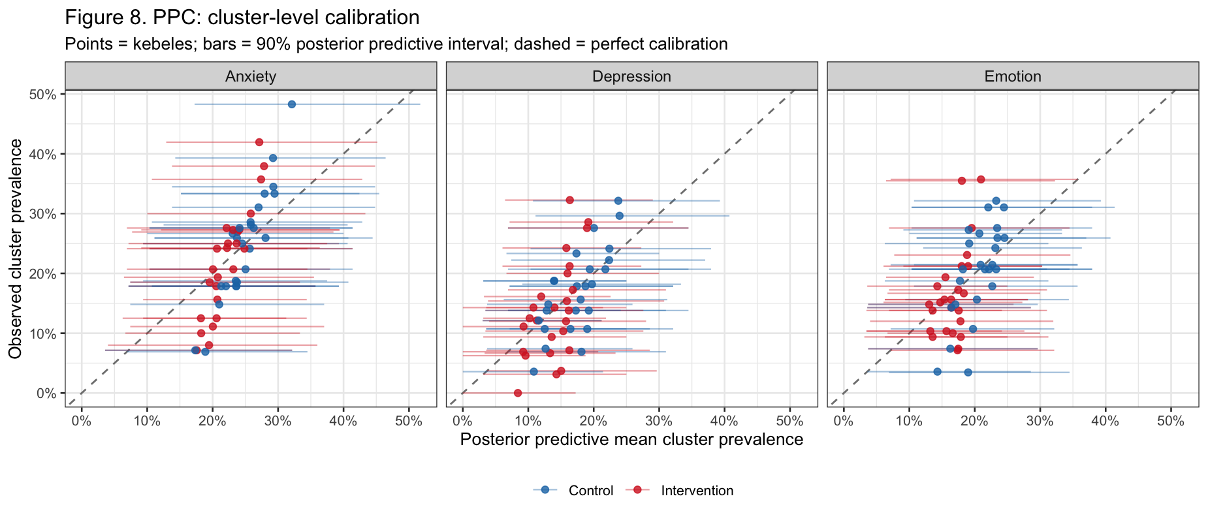

Discussion
Andilaye WASH intervention shows no practically meaningful effect on any of the three mental health outcomes at endline. Posterior APDs are small and consistently negative across all outcomes, with most posterior mass falling inside the ROPE. Between-kebele clustering is modest, confirming that random intercepts were a necessary modeling choice, but community membership explains relatively little of the variation in household mental health in this population. Taken together, the data provide substantial positive evidence for a practically null effect rather than merely insufficient evidence against one, moving the conclusion beyond the binary fail-to-reject framing of the original frequentist analysis.
This study has some limitations. First, this is a secondary reanalysis not pre-registered as a Bayesian analysis, which limits the strength of inference claims relative to a prospective design. Outcomes are based on responses from women of reproductive age as the household respondent, and may not reflect the mental health of other household members, limiting generalizability to the full household population. Incomplete intervention fidelity attenuates any detectable effect and must be considered when interpreting the null findings: the ROPE analysis establishes that the delivered intervention had no meaningful effect, not that an ideally implemented WASH intervention would not. Computationally, the Gibbs sampler showed persistent autocorrelation of $β_{\text{trt}}$and slow mixing of $σ_{\text{cluster}}$, a known limitation of Gibbs sampling in hierarchical logistic models.
The most immediate computational improvement would be to refit this model in brms (Bürkner, 2017), which uses Hamiltonian Monte Carlo with the non-centered parameterization by default and might resolve both mixing issues while providing automatic LOO and posterior predictive checks. Substantively, three extensions are directly motivated by the study design and the limitations identified above. First, a varying-slopes specification would allow the treatment effect to differ across woredas, replacing the single $β_{\text{trt}}$with woreda-specific effects partially pooled toward a grand mean, which is motivated by the documented variation in intervention fidelity across sites (Freeman et al., 2022). Second, a three-level hierarchical structure explicitly modeling households within kebeles within woredas would replace the current woreda fixed effects with a third random level, properly partitioning variance across all three levels of the design and providing a full posterior distribution for woreda-level heterogeneity rather than fixed point estimates. Third, incorporating additional household-level covariates, such as wealth, education, or baseline water and sanitation access, might reduce residual variance at the household level and sharpen the estimate of $β_{\text{trt}}$, while also allowing examination of whether the treatment effect is modified by pre-existing household characteristics.

Appendix: Weakly Informative Priors
Here we reported prior predictive checks, posterior inferences, posterior predictive checks, and model comparisons using weakly informative priors:$μ_{0}∼Normal(0, 1^{2})$and$σ_{\text{clus}\text{ter}}∼\text{Half-}t(3, 0, 2.5)$).
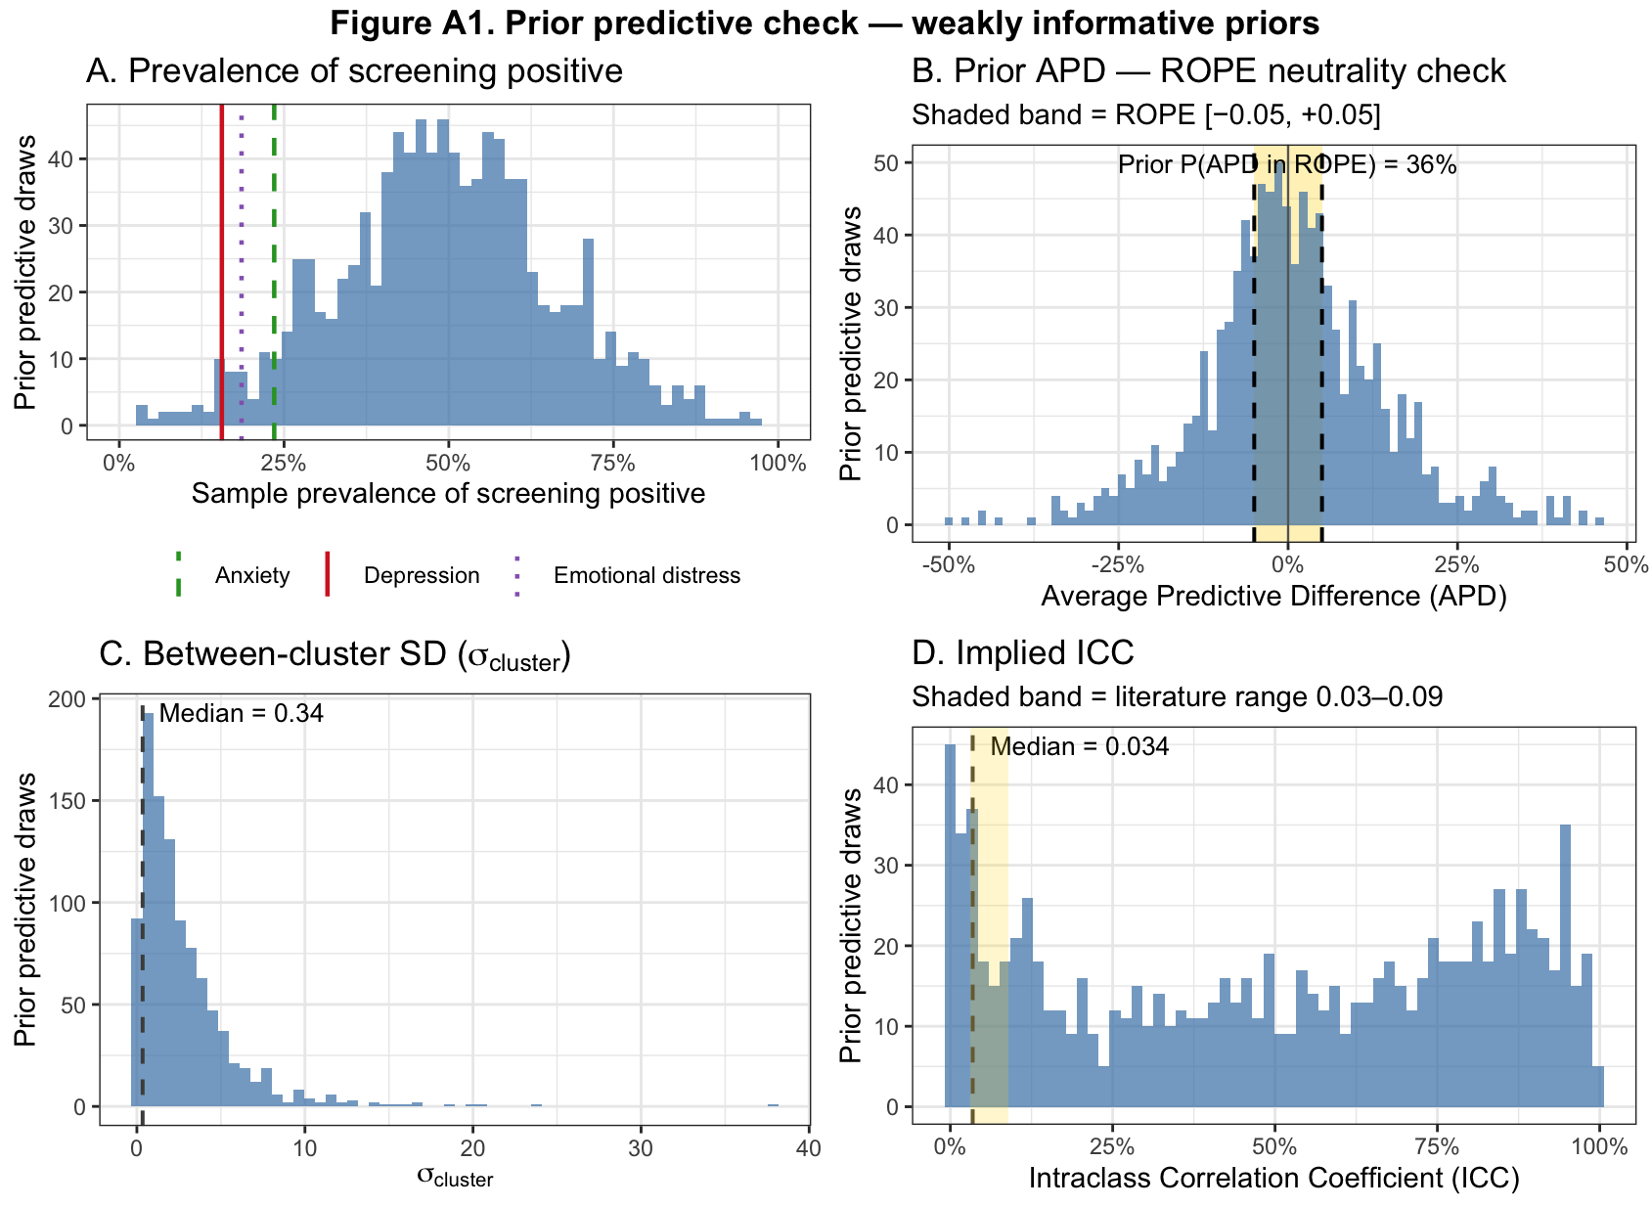
Table A1. Posterior Average Predictive Difference – weakly informative priors.
Outcome | APD | 95% HDI | P(ROPE) | NNT
Anxiety | -0.027 (0.026) | [-0.078, 0.024] | 81.2% | 37
Depression | -0.031 (0.021) | [-0.072, 0.008] | 82.2% | 32
Emotion | -0.039 (0.022) | [-0.081, 0.004] | 69.1% | 26
Note: APD reported as posterior mean (SD). 95% HDI = Highest Density Interval. P(ROPE) = posterior probability that |APD| < 0.05. NNT = Number Needed to Treat, computed as 1/|mean APD|. ROPE = Region of Practical Equivalence [-0.05, +0.05].

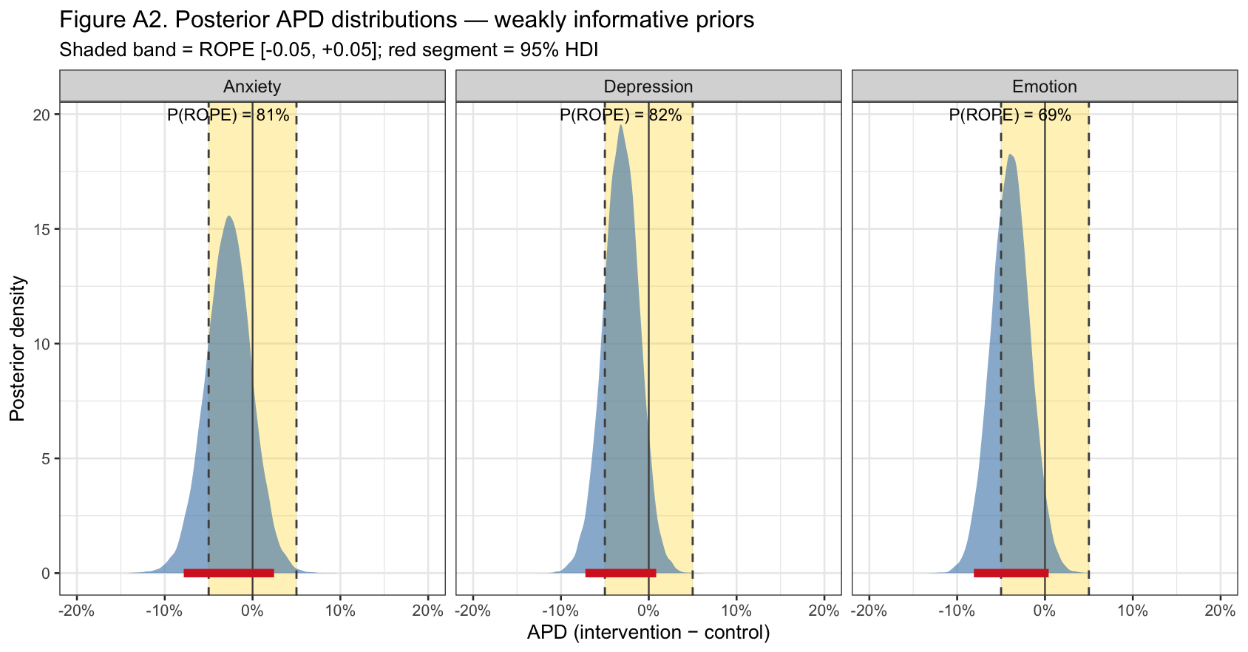
Table A2. Posterior Between-Cluster Variance – weakly informative priors
Outcome | $$σ_{cluster}$$ | ICC
Anxiety | 0.274 [0.025, 0.470] | 0.026 [0.000, 0.060]
Depression | 0.212 [0.000, 0.428] | 0.018 [0.000, 0.053]
Emotion | 0.189 [0.000, 0.389] | 0.014 [0.000, 0.044]
Note: All estimates reported as posterior mean [95% Highest Density Interval].
$σ_{cluster}$ = between-kebele standard deviation on the log-odds scale. ICC = Intraclass Correlation Coefficient, computed draw-by-draw as $\frac{σ_{cluster}^{\left(s\right)2}}{\frac{π^{2}}{3} + σ_{cluster}^{\left(s\right)2}}$, where $\frac{π^{2}}{3}$ is the variance of the standard logistic distribution.

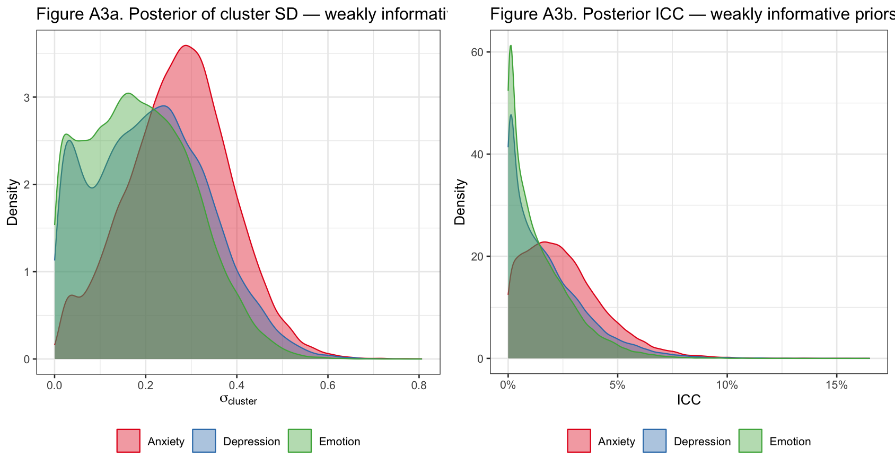
Table A3. Posterior predictive p-values (PPP-values) – weakly informative priors
 | Anxiety |  | Depression |  | Emotion
Statistic | Obs. | PPP | Obs. | PPP | Obs. | PPP
Overall prevalence | 0.235 | 0.523 | 0.156 | 0.537 | 0.185 | 0.534
Treatment arm | 0.222 | 0.515 | 0.141 | 0.513 | 0.167 | 0.512
Control arm | 0.248 | 0.524 | 0.170 | 0.539 | 0.204 | 0.541
Woreda: Farta | 0.240 | 0.529 | 0.165 | 0.545 | 0.197 | 0.542
Woreda: Fogera | 0.245 | 0.510 | 0.198 | 0.502 | 0.204 | 0.507
Woreda: Bahir Dar Zuria | 0.222 | 0.512 | 0.113 | 0.524 | 0.157 | 0.513
Cluster prevalence SD | 0.092 | 0.550 | 0.079 | 0.617 | 0.080 | 0.653
Note: PPP-values near 0.5 indicate good calibration. Values near 0 or 1 indicate systematic discrepancy.

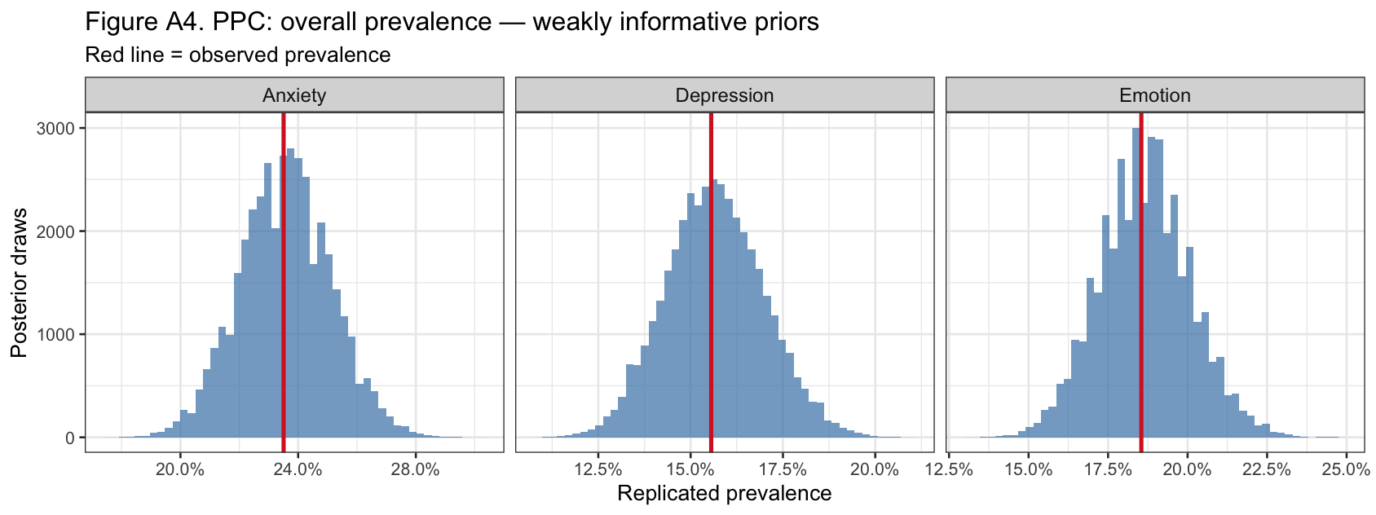
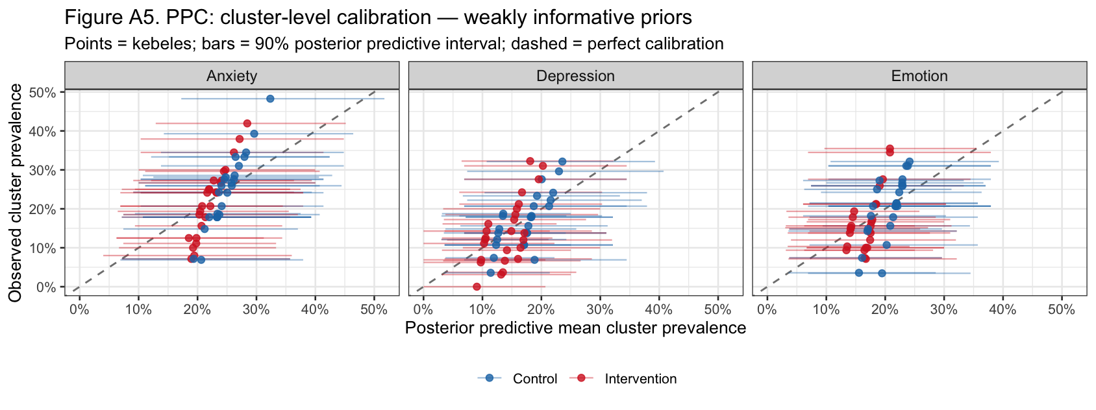
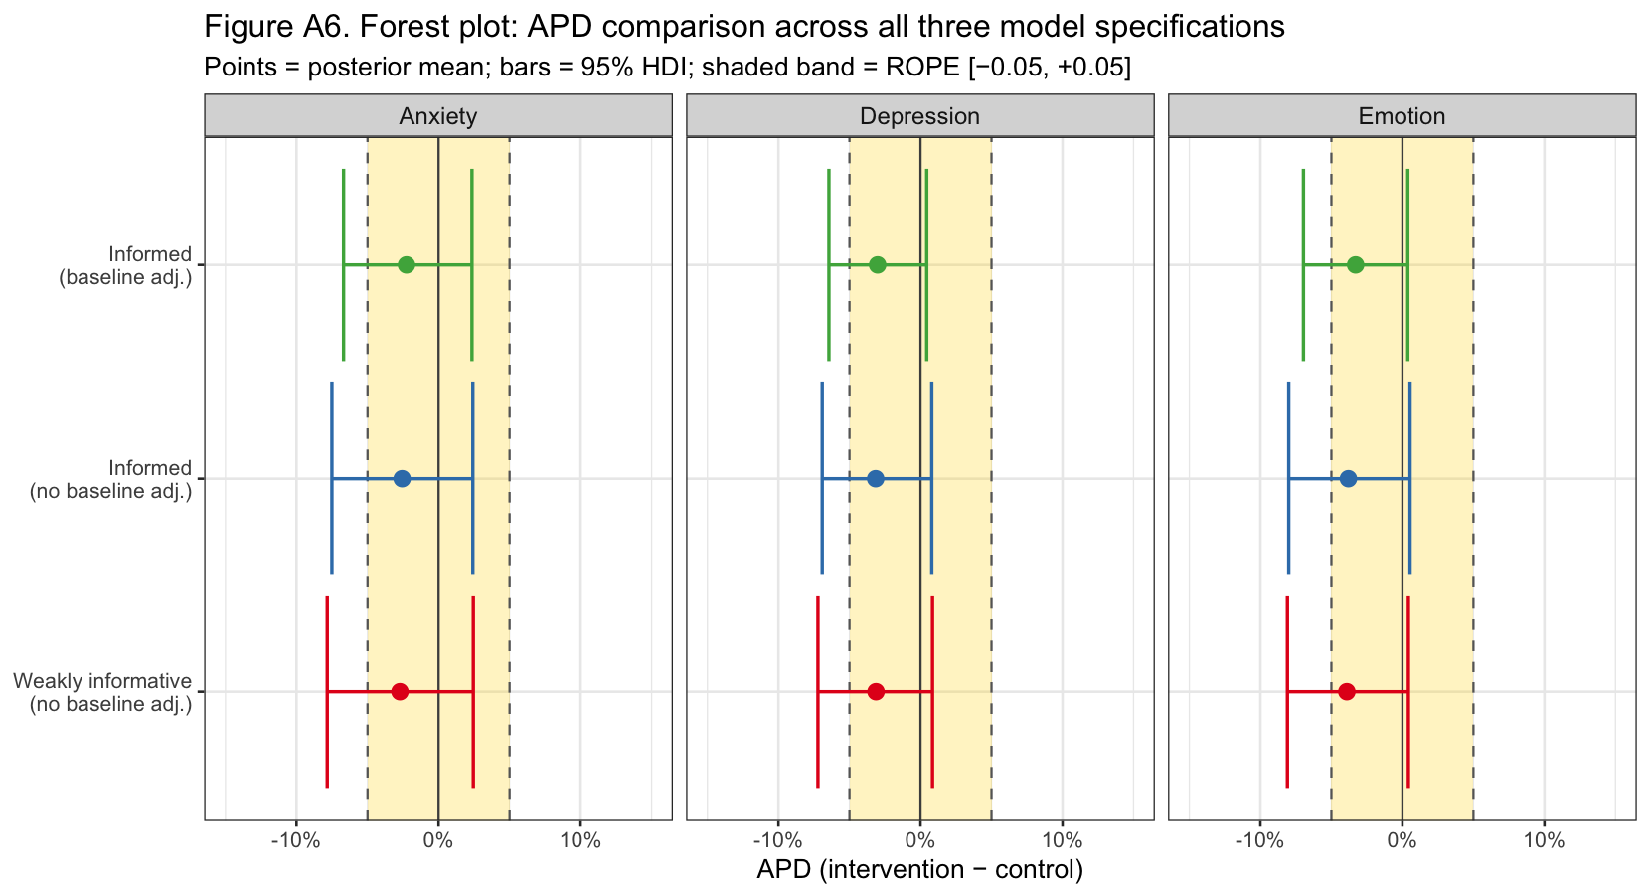

References
Bhaskarapillai, B., Malo, P. K., Kishore, M. T., Joseph, A., Majhi, G., Jaisoorya, T. S., & Kandavel, T. (2025). Intraclass Correlation in Cluster Randomized Controlled Trials: A Meta-Analysis of Studies on Major Depression. Indian Journal of Psychological Medicine, 47(6), 549–556. https://doi.org/10.1177/02537176241293194
Bürkner, P.-C. (2017). brms: An R Package for Bayesian Multilevel Models Using Stan. Journal of Statistical Software, 80, 1–28. https://doi.org/10.18637/jss.v080.i01
Delea, M. G., Snyder, J. S., Belew, M., Caruso, B. A., Garn, J. V., Sclar, G. D., Woreta, M., Zewudie, K., Gebremariam, A., & Freeman, M. C. (2019). Design of a parallel cluster-randomized trial assessing the impact of a demand-side sanitation and hygiene intervention on sustained behavior change and mental well-being in rural and peri-urban Amhara, Ethiopia: Andilaye study protocol. BMC Public Health, 19(1), 801. https://doi.org/10.1186/s12889-019-7040-6
Freeman, M. C., Delea, M. G., Snyder, J. S., Garn, J. V., Belew, M., Caruso, B. A., Clasen, T. F., Sclar, G. D., Tesfaye, Y., Woreta, M., Zewudie, K., & Gobezayehu, A. G. (2022). The impact of a demand-side sanitation and hygiene promotion intervention on sustained behavior change and health in Amhara, Ethiopia: A cluster-randomized trial. PLOS Global Public Health, 2(1), e0000056. https://doi.org/10.1371/journal.pgph.0000056
Gelman, A. (2006). Prior distributions for variance parameters in hierarchical models (comment on article by Browne and Draper). Bayesian Analysis, 1(3), 515–534. https://doi.org/10.1214/06-BA117A
Kruschke, J. K. (2018). Rejecting or Accepting Parameter Values in Bayesian Estimation. Advances in Methods and Practices in Psychological Science, 1(2), 270–280. https://doi.org/10.1177/2515245918771304
Williams, N. J., Cardamone, N. C., Beidas, R. S., & Marcus, S. C. (2024). Calculating power for multilevel implementation trials in mental health: Meaningful effect sizes, intraclass correlation coefficients, and proportions of variance explained by covariates. Implementation Research and Practice, 5, 26334895241279153. https://doi.org/10.1177/26334895241279153

